The role of the foreshock in the solar wind-magnetosphere interaction

D. G. Sibeck

Heliophysics Division, NASA/GSFC, Greenbelt, MD 20771 USA

Kinetic processes within the foreshock introduce considerable variability into the solar wind-magnetosphere interaction, far greater than that seen in the pristine solar wind. A host of transient events have been identified within the foreshock, including hot flow anomalies, spontaneous hot flow anomalies, cavities, bubbles, and cavitons. The structures share some common features: large amplitude (factor of 3 or more) correlated density and magnetic field strength variations on interplanetary magnetic field lines connected to and just upstream from the bow shock. When the events strike the bow shock, they launch both fast mode waves and narrow jets that propagate across the magnetosheath and strike the magnetosphere. The significance of the foreshock structures lies in the wide array of magnetospheric phenomena that they generate: large amplitude bow shock and magnetopause motion, ULF waves throughout the dayside magnetosphere, compressional perturbations that can drive radial diffusion of radiation belt particles, and traveling convection vortices in high latitude ground magnetograms, to name but a few. This presentation reviews the array of upstream events and the corresponding magnetospheric features, relying in part upon recent rapid developments in both global magnetohydrodynamic and hybrid code models.
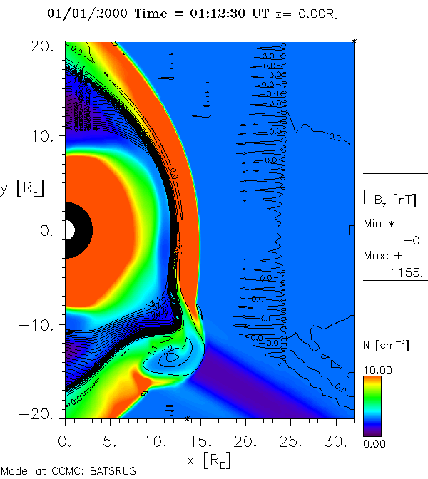
This figure shows the interaction of a slab of interplanetary magnetic fields connected to the bow shock with the magnetosphere. There are depressed densities and magnetic field strengths within the slab, but enhanced temperatures. Depressed pressures within the slab enable both the bow shock and magnetopause to bulge outward several earth radii.

