Study of the longitudinal effect of auroral absorption in the Arctic zone

A.V. Frank-Kamenetsky, S.A. Dolgacheva
Arctic and Antarctic research institute, St. Petersburg, Russia

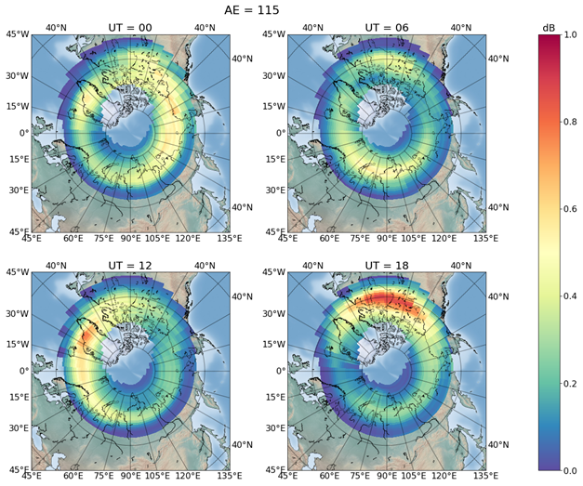
The purpose of this work was to study the longitudinal effect in the distribution of auroral absorption intensity at different levels of magnetic activity for different world time intervals based on data from the Canadian meridional chain of stations, taking into account geographic latitude. Hourly average values of the AE index were used as a characteristic of magnetic activity, since the AE index characterizes magnetic activity in the aurora zone, where auroral absorption is observed. For selected periods, latitudinal absorption profiles were calculated for each UT hour. To obtain a global picture of the absorption distribution, moving along the magnetic parallel, we transferred the data from the Canadian meridional chain to other geographic latitudes. To correct the absorption value by geographic latitude, we examined data from 3 riometers located at close magnetic latitudes, but at significantly different geographic latitudes and obtained a correction factor (A= А₀ * ΔGLat* 0.025, where A₀ absorption at Canadian chain). The results obtained made it possible to construct maps of the distribution of maximum absorption values for different levels of magnetic activity and for 4 moments of UT (00, 06, 12, and 18 UT). An example of such a map for AE = 115 nT is shown in the figure. The resulting distribution maps of auroral absorption intensity make it possible to estimate the expected absorption for various conditions of magnetic activity and in certain geographical areas.

